**A**

PROJECT REPORT

ON

*“ONLINE Movie Ticket BookinG ”*

SUBMITTED TO



Punyashlokahilyadeviholkar

SOLAPUR university SOLAPUR

BY

Miss .Magar Aishwarya Balasaheb

**BACHELOR OF SCIENCE [E.C.S.]**

Shriram Institute of Information Technology, Paniv

**[2019-2020]**

**Under The Guidance Of**

**Prof. Miss. Honrao.C.P**

“Shriram Shikshan Santha’s”

SHRIRAM INSTITUTE OF INFORMATION TECHNOLOGY,PANIV.

Tal:-Malshiras, Dist:-Solapur.



CERTIFICATE

Date: / /2020

This is to certify that the report entity  **“Online Movie Ticket Booking”** has been carried out by Miss .Magar Aishwarya Balasaheb . In project fulfillment for award of Degree in Bachelor of Science(BCS – III sem – VI) as per the requirement of Punyashlok ahilyadevi holkar SOLAPUR university, SOLAPUR in academic year 2019-2020.

SEEN BY

Project Guide External Examiner Head of Department

**ACKNOWLEDGEMENT**

The development of system involves contribution of time & efforts of many peoples. We have acknowledged their help individually by expressing our hearts gratitude to all of them.

We must express our sincere thanks to principal **Dr. Pawar S. A.** and head of department Mr**. Dawkare R. R.** & ***Prof. Miss. Honrao.C.P*** entire staff for their valuable guidance & supports. Our deep sense of gratitude also goes to all friends who help us for successful completion of project.

We must express our sincere thanks to ***Prof. Miss. Honrao.C.P*** for giving more valuable & more details information about **“ Online Movie Ticket Booking”.**

This report would not be in your hands without the help of many besides of our self. We must express our gratitude towards our projects guide ***Prof. Miss. Honrao.C.P* for** his guidance & giving us good direction while working on project.

Every work is outcome of full proof planning, continuous hard work and organized

**Thanking You,**

Miss .Magar Aishwarya Balasaheb

***INDEX***

|  |  |
| --- | --- |
| **No** | **Content name** |
| 1 | Introduction |
| 2 | Scope Of Project  2.1)Existing System  2.2)Need Of Computerized system  2.3)Objective |
| 3 | Requirement Analysis  3.1)Feasibility Study  3.1.1)Technical Feasibility Study  3.1.2)Operational Feasibility Study  3.1.3)Economical Feasibility Study |
| 4 | System Requirement  4.1)Software Requirement  4.2)Hardware Requirement |
| 5 | System Analysis  5.1)ERD  5.2) CLD  5.3)DFD |
| 6 | Database Layout |
| 7 | Screen Layout |
| 8 | Technology Used To Develop a System |
| 9 | Limitation Of Current System |
| 10 | Bibliography |

**INTRODUCTION**

The “ Online Movie Ticket Booking “ has been developed to override the problems prevailing in the practicing manual system. This software is supported to eliminate and in some cases reduce the hardships fased by this existing system. Moreover this system is designed for the particular need of Student to carry out operation in a smooth and effective manner.

The application is reduced as much as possible to avoid errors while entering the data .it also provides error message while entering invalid data. No formal knowledge needed for the user to use this system. Thus by this all it proves it is user friendly medical shop management system as described above, can lead to error free ,secure, reliable and fast management system. it can assist the user concentrate on their other activities rather to concentrate on the record keeping thus it will help organization in better utilization of resources

**Existing System**

1. Lack of security of data
2. More man power
3. Time consuming.
4. Consumes large volume of pare work.
5. Needs of manual calculations.
6. No direct role for the higher officials.

**OBJECTIVE**

* System Objective:-

1. Movie Ticket Booking is system to managed detailed of Seats,Booking,

Customer, Payment, shows.

1. It manages all the information about Seats, Movie, Shows.
2. The project is totally built at administrative end and thus only the administrator is guaranteed the access .
3. The purpose of the project is to build an application program to reduce the manual work for managing the Seats, Booking ,Movie, Customer.

**SCOPE OF SYSTEM**

1. This System can be used to manage Theater Show.
2. Sms notification after successful seat reservation.
3. Allow customers to comment on movies.
4. Any institute can book the ticket for students/clients & special discount will be provided to them.

**PURPOSE OF SYSTEM**

The purpose of this System as follows:

1. Provide anytime any place service for the customer.
2. Provide effective solutions for easy availability of movie ticket.
3. Provide simpler way to choose our seat & area for movie show.
4. To minimize the number of staff at the ticket box.
5. To promote movies the movies on the web.
6. Try to increase profit as much as possible.

**OPERATING ENVIRONMENT**

* + - **SYSTEM REQUIREMENT**

**System development using following hardware configuration**

Processor : CORE (E1) DUAL CPU.

RAM : 2 GB RAM.

HDD : 512 GB

**System development using following software**

Operating System: Windows 10.

Developing Tool : Visual studio 2010.

Database : Sql Server .

**FEASIBILITY STUDY**

System Analysis is a management technique, which helps in designing a new system. System Analysis is the process of gathering and interpreting facts, diagnosing problems (if any), using information to recommend improvements to the system. There are four basic elements of system analysis: - Output, Input, Files, processes. For computerization of any system, the existing system must be thoroughly being understood to determine “how the computer can be best used to make its operation most effective”. This is acquired by analyzing existing system.

1. Technical Feasibility

2. Economical Feasibility

3. Operational Feasibility

**1. Technical Feasibility**

Technical feasibility determines whether the work for the project can be done with the existing equipment, software technology and available personnel. Technical feasibility is concerned with specifying equipment and software that will satisfy the user requirement.

This project is feasible on technical remarks also, as the proposed system is more beneficiary in terms of having a sound proof system with new technical components installed on the system. The proposed system can run on any machines supporting Windows services and works on the best software and hardware that had been used while designing the system so it would be feasible in all technical terms of feasibility.

**2. Economical Feasibility**

Economical feasibility determines whether there are sufficient benefits in creating to make the cost acceptable, or is the cost of the system too high. As this signifies cost-benefit analysis and savingsss. On the behalf of the cost-benefit analysis, the proposed system is feasible and is economical regarding its pre-assumed cost for making a system.

We classified the costs of window-SHOP according to the phase in which they occur. As we know that the system development costs are usually one-time costs that will not recur after the project has been completed. For calculating the Development costs we evaluated certain cost categorize.

1. Personal costs

2. Computer usage

3. Supply and equipments costs

4. Cost of any new computer equipments and software.

**3. Operational Feasibility**

Operational feasibility criteria measure the urgency of the problem (survey and study phases) or the acceptability of a solution (selection, acquisition and design phases). How do you measure operational feasibility? There are two aspects of operational feasibility to be considered

**System Analysis**

**(ERD)** **ENTITY RELATIONSHIP DIAGRAM:-**

Admin

Add

M

1

Movies

User

Select

Depends On Movie

1

1

Book

1

1

Book

Payment

1

1

**CL D (Context Level Diagram)**

Admin

User

Select Movie

Add Movies

Book Ticket

User

Payment

Select Movie

Book Ticket

Payment

**DFD (Data Flow Diagram):-**

Admin

Add Movie Info

Add movies

User

Select Movie

Request to Book

Book

Payment

**Database Layout**

**Booking Database Table:-**

|  |  |  |
| --- | --- | --- |
| **Column Name** | **DataType** | **Allow Nulls** |
| Mname | Varchar(MAX) |  |
| Cdate | Varchar(50) |  |
| Ctime | Varchar(50) |  |
| Type | Varchar(50) |  |
| Seats | Varchar(50) |  |
| a1 | Int |  |
| a2 | Int |  |
| a3 | Int |  |
| a4 | Int |  |
| a5 | Int |  |
| a6 | Int |  |
| a7 | Int |  |
| a8 | Int |  |
| a9 | Int |  |
| a10 | Int |  |
| Total | Int |  |

***INPUT SCREEN***

***1.Home page .***

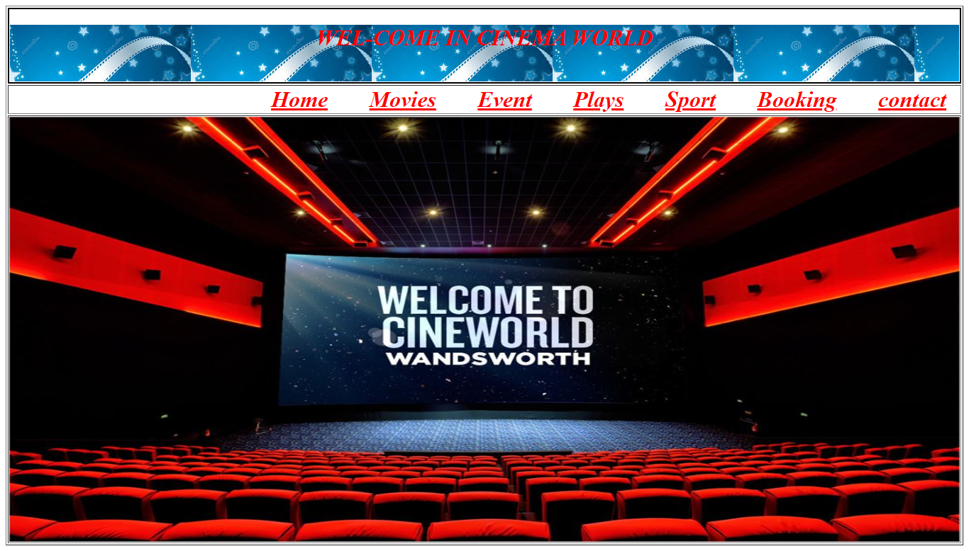

***2.Movies page .***

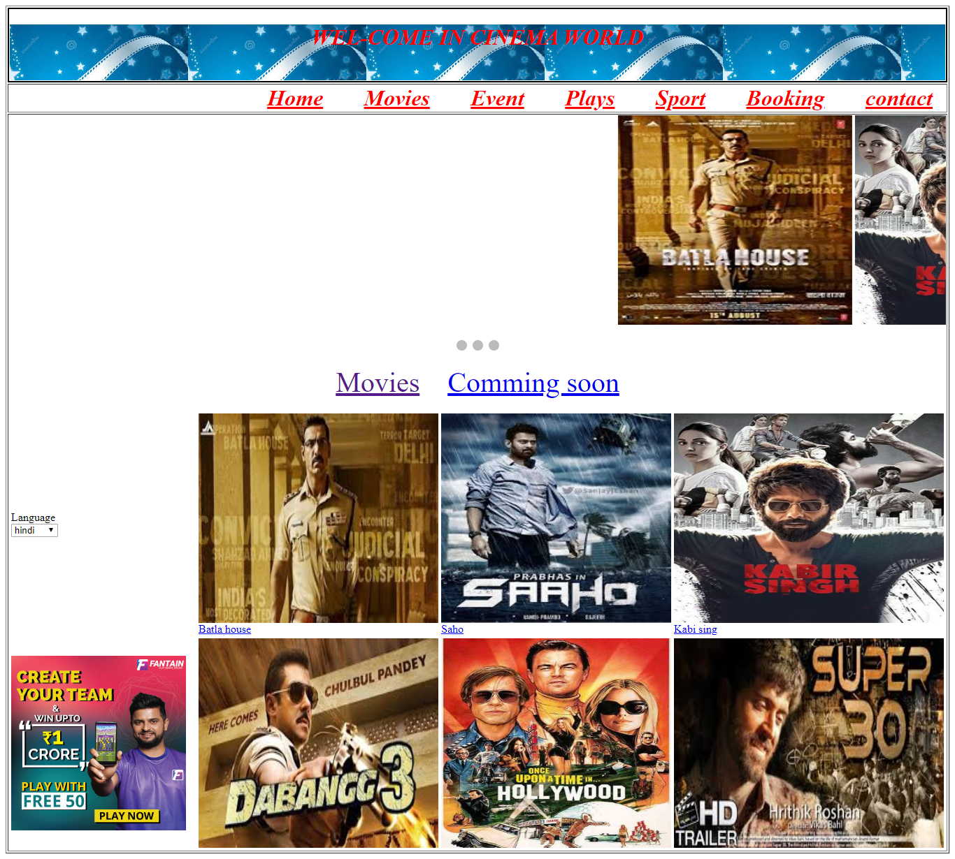

***3.Event page .***

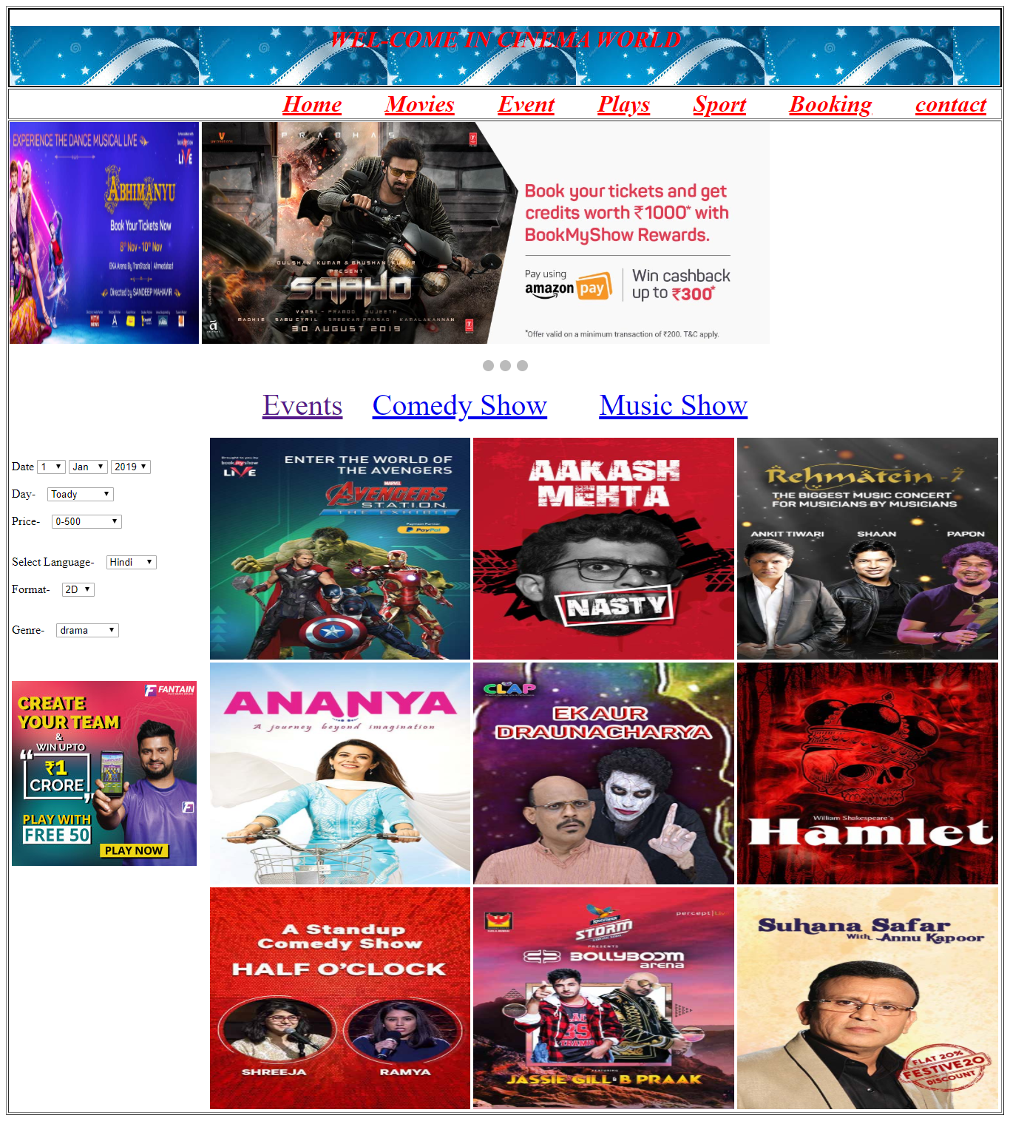

***4.Plays page .***

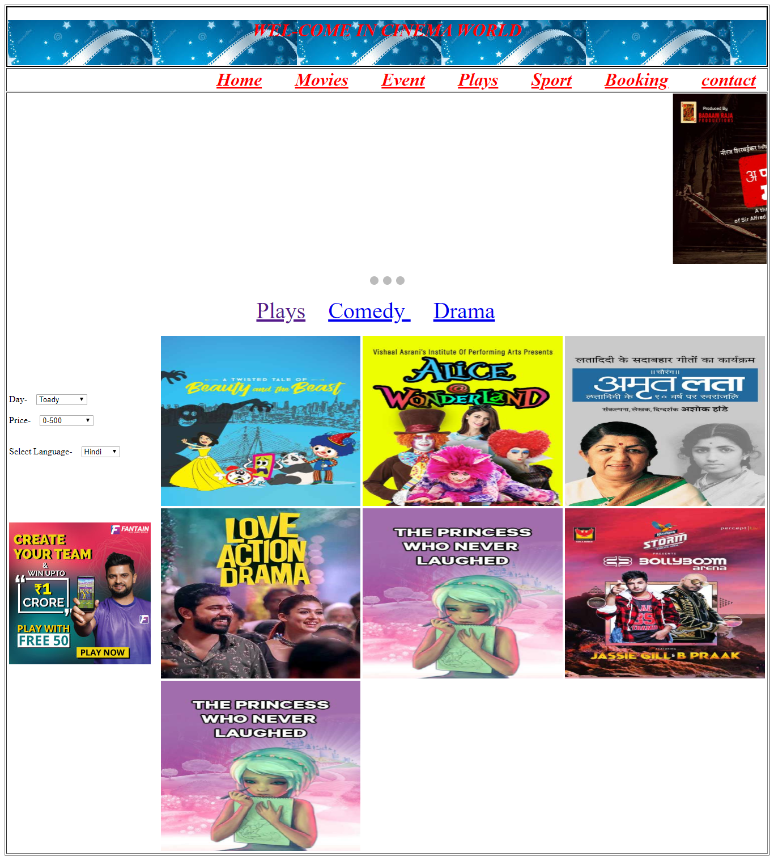

***5.Sport page .***

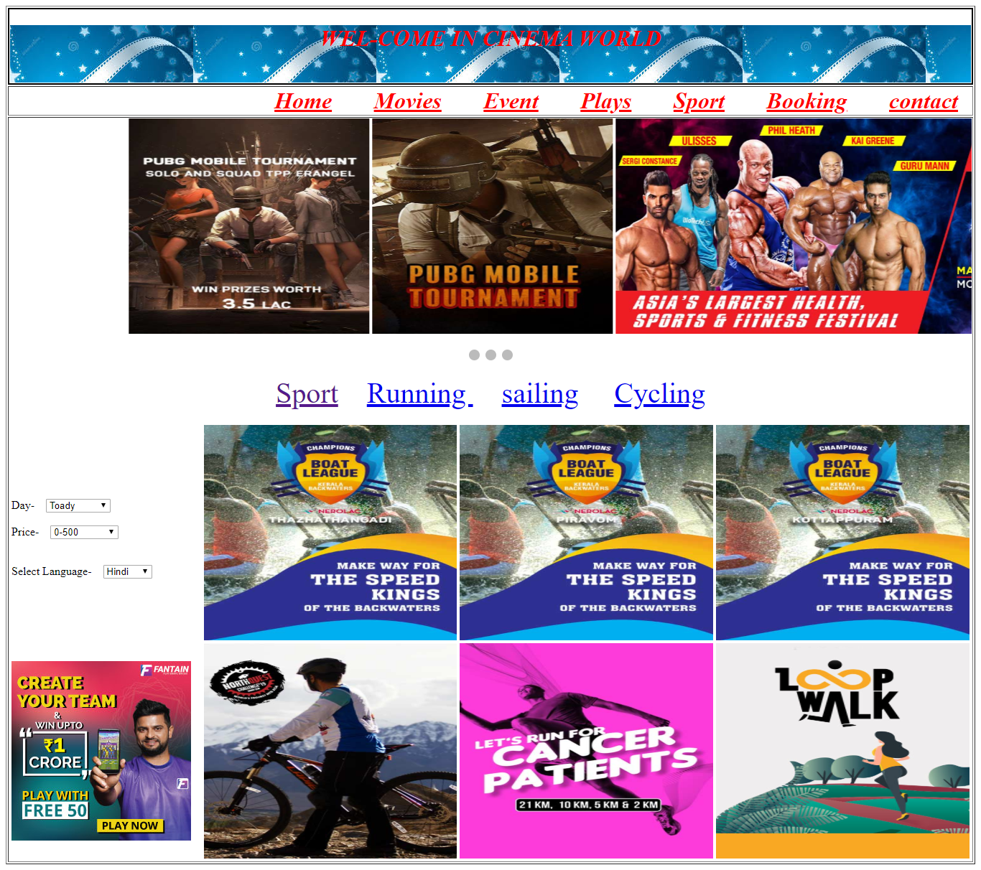

***6.Contact page .***

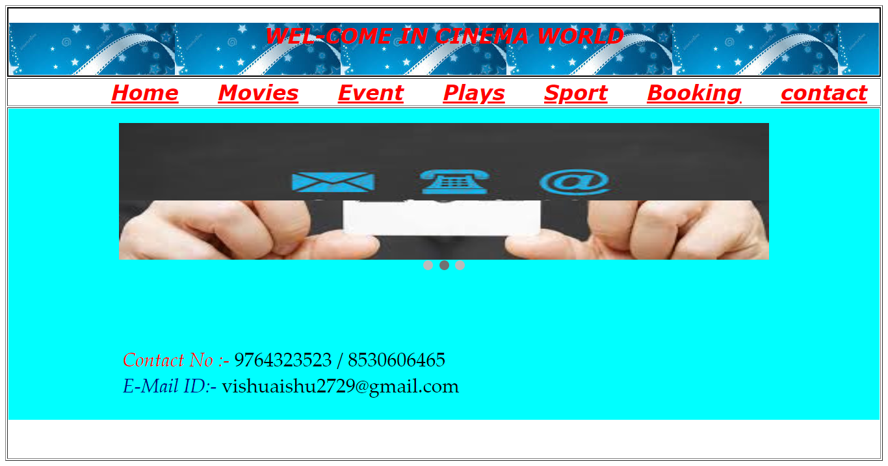

***7.Booking page .***

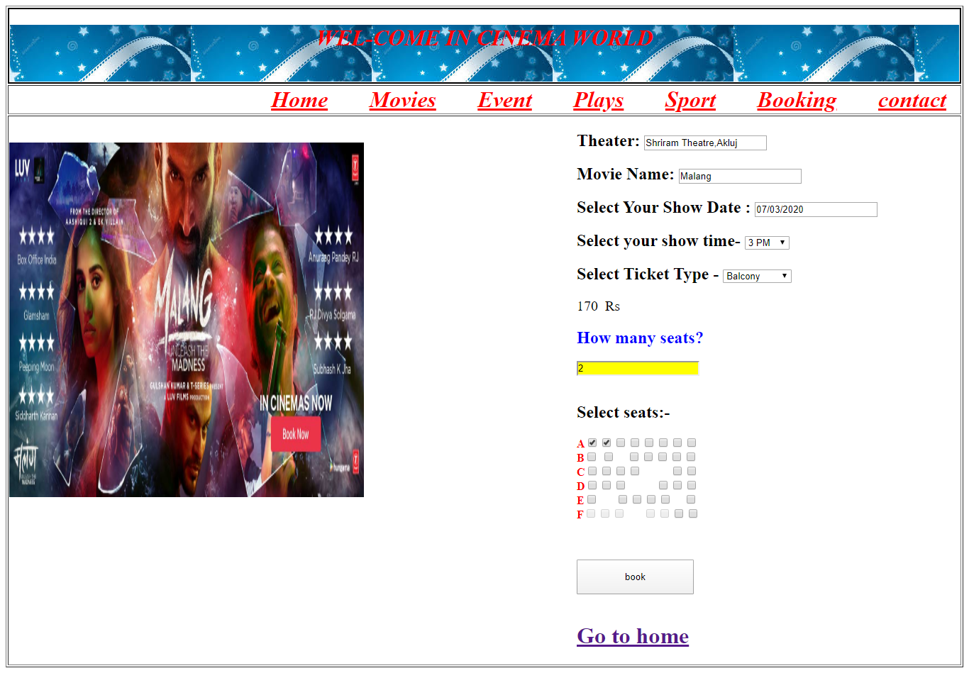

***8.Payment page .***

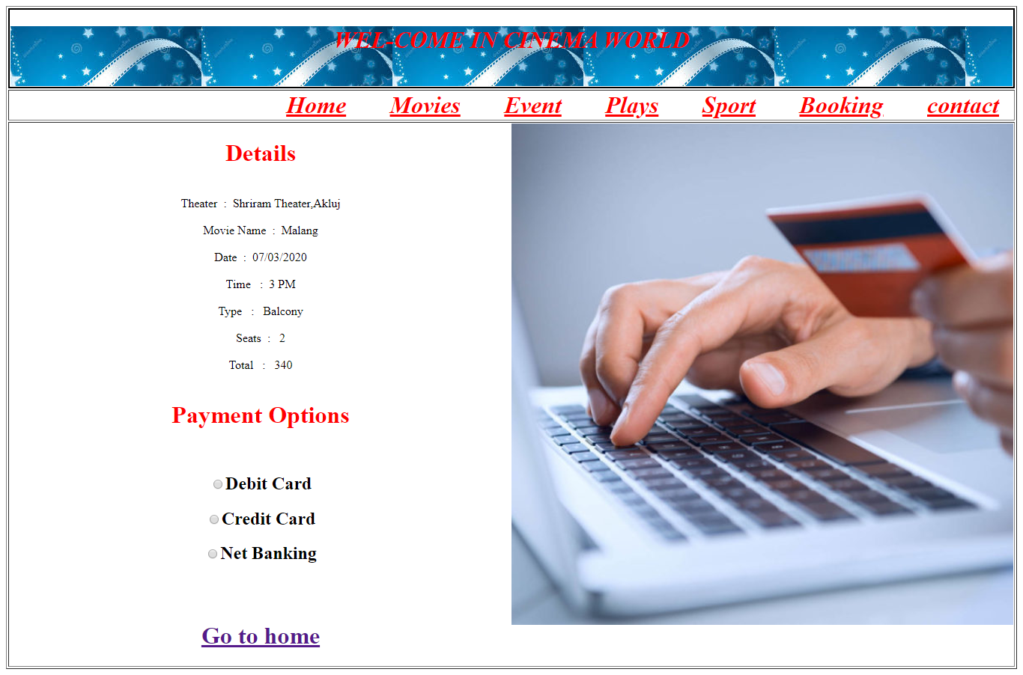

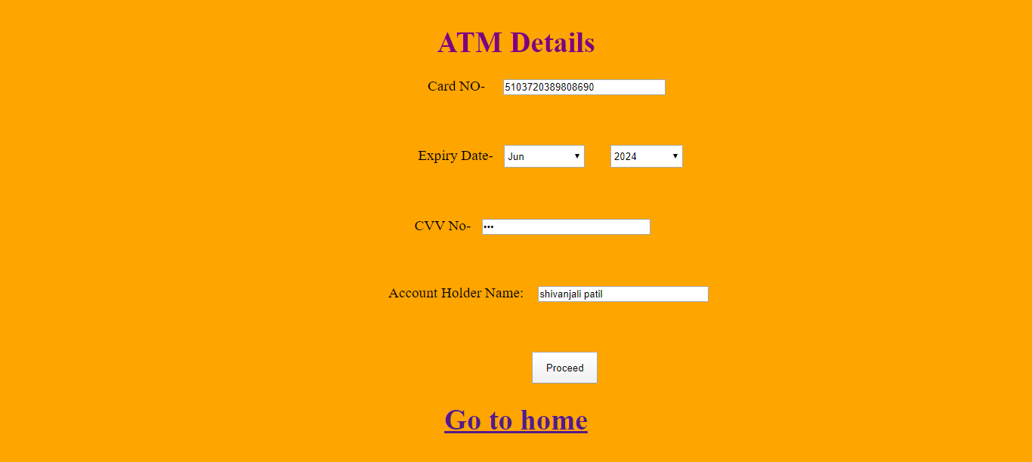

***10.Booking Information page .***

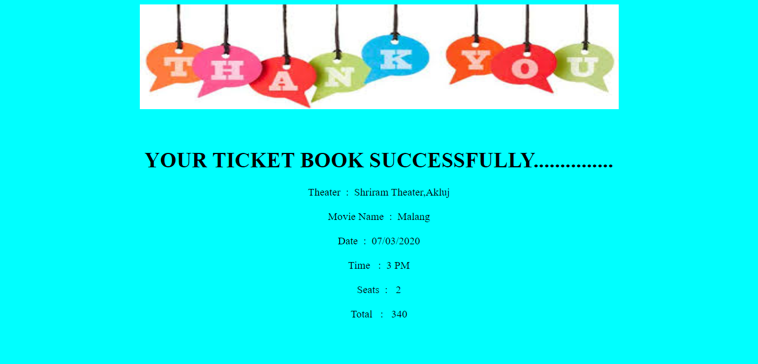

***LIMITATION OF SYSTEM***

1. This system runs on windows 10 professional & visual studio 2010.
2. Seat reservation history is not recorded.
3. Admin cannot maintain customer details.
4. No backup and restore utilities are incorporated.

***BIBLIOGRAPHY***

1. Visual programming c# 2008 by work publication.

2. Window application development with c# by Microsoft press

No:-70-315.

3. We refer the website WWW.BOOK MYSHOW .COM.